Satellite Repeater

🛰️ What is a Satellite Repeater?
# Source: AI Source: Provided by: [Data Path: Persons Table -> ID Column: 1, Name_En Column: Motasem Essam] -> From: [ChatGPT] on [12/18/2025]
A Satellite Repeater, also known as a satellite transponder, is a device located onboard a communication satellite that receives signals from Earth, amplifies them, and retransmits them back to a different location on Earth — usually on a different frequency.
✅ Think of it as a wireless repeater in space — it helps relay signals over vast distances across the globe.

🔄 How It Works
# Source: AI Source: Provided by: [Data Path: Persons Table -> ID Column: 1, Name_En Column: Motasem Essam] -> From: [ChatGPT] on [12/18/2025]
- A ground station (uplink) transmits a radio signal to the satellite.
- The satellite’s repeater (transponder) receives the signal.
- It amplifies the signal and shifts its frequency (to avoid interference).
- The repeater then retransmits it back to another ground station (downlink).

📡 Basic Satellite Repeater System
# Source: AI Source: Provided by: [Data Path: Persons Table -> ID Column: 1, Name_En Column: Motasem Essam] -> From: [ChatGPT] on [12/18/2025]
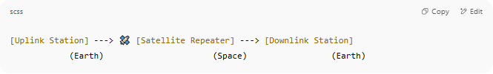
[Uplink Station] ---> 🛰️ [Satellite Repeater] ---> [Downlink Station]
(Earth) (Space) (Earth)

- Uplink and downlink operate on different frequencies (e.g., uplink on 6 GHz, downlink on 4 GHz for C-band).

🔧 Key Functions
# Source: AI Source: Provided by: [Data Path: Persons Table -> ID Column: 1, Name_En Column: Motasem Essam] -> From: [ChatGPT] on [12/18/2025]
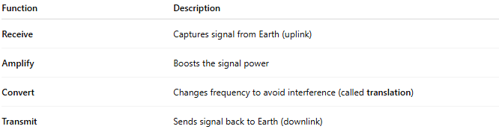

Function | Description
Receive | Captures signal from Earth (uplink)
Amplify | Boosts the signal power
Convert | Changes frequency to avoid interference (called translation)
Transmit | Sends signal back to Earth (downlink)

🧠 Types of Satellite Repeaters (Transponders)
# Source: AI Source: Provided by: [Data Path: Persons Table -> ID Column: 1, Name_En Column: Motasem Essam] -> From: [ChatGPT] on [12/18/2025]
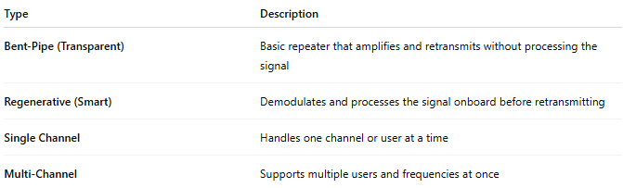

Type | Description
Bent-Pipe (Transparent) | Basic repeater that amplifies and retransmits without processing the signal
Regenerative (Smart) | Demodulates and processes the signal onboard before retransmitting
Single Channel | Handles one channel or user at a time
Multi-Channel | Supports multiple users and frequencies at once

🌍 Use Cases
# Source: AI Source: Provided by: [Data Path: Persons Table -> ID Column: 1, Name_En Column: Motasem Essam] -> From: [ChatGPT] on [12/18/2025]
- TV broadcasting (e.g., satellite TV)
- Global telephone and internet links
- Military and defense communication
- Remote area connectivity
- Emergency communications when terrestrial links fail

✅ Pros
# Source: AI Source: Provided by: [Data Path: Persons Table -> ID Column: 1, Name_En Column: Motasem Essam] -> From: [ChatGPT] on [12/18/2025]
- ✅ Enables global communication
- ✅ Works over long distances, including oceans and mountains
- ✅ Reliable for broadcasting and remote access

❌ Cons
# Source: AI Source: Provided by: [Data Path: Persons Table -> ID Column: 1, Name_En Column: Motasem Essam] -> From: [ChatGPT] on [12/18/2025]
- ❌ High latency (especially in geostationary satellites)
- ❌ Expensive to deploy and maintain
- ❌ Weather and obstacles can affect signal quality

📌 Summary
# Source: AI Source: Provided by: [Data Path: Persons Table -> ID Column: 1, Name_En Column: Motasem Essam] -> From: [ChatGPT] on [12/18/2025]
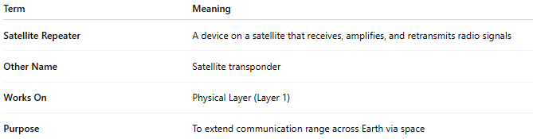

Term | Meaning
Satellite Repeater | A device on a satellite that receives, amplifies, and retransmits radio signals
Other Name | Satellite transponder
Works On | Physical Layer (Layer 1)
Purpose | To extend communication range across Earth via space

